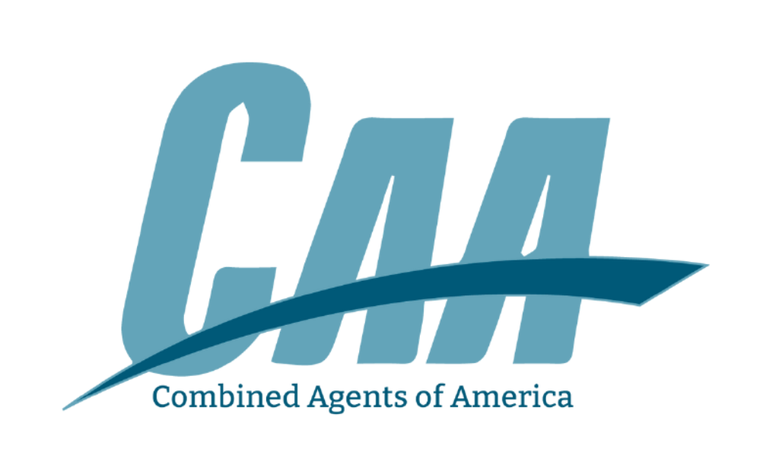

MINUTES
COMBINED AGENTS OF AMERICA, LLC
Las Colinas | Dallas, TX
July 17-18, 2024

Wednesday, July 17, 2024

The CAA Board of Members meeting was held at the Omni Las Colinas in Dallas, TX.

All member agencies were represented except the following:

- Relion Insurance
- TR Baker Insurance
- Davis & Garratt

BUSINESS MEETING

Chairman Bob Wood called the meeting to order.

- CONSENT AGENDA

Bob Wood asked for a motion to consent to the agenda and approve the minutes from the February 2024 meeting.

MOTION WAS MADE BY Michael Bosworth. AND SECONDED BY Clifton Fendley. MOTION CARRIED.

- FINANCIAL REPORT

Prospect from Warrenton, Missouri - Scott Costello - Referral by Al Jannett.

CAA CEO A.J. Lovitt presented the financials to the board.

MOTION WAS MADE TO APPROVE FINANCIALS BY David Wellmann AND SECONDED BY Kyle Becker. MOTION CARRIED.

- CEO/COO UPDATE/Q&A - (AJ BOM Powerpoint)
- Membership Update
  - Lost 18 members since 2021
  - Need to continue to get quality members
  - 80 members currently
  - Expand outside our current states
  - Keystone sold to PE - Opportunity there for recruiting Keystone members left in those states
  - CAA is prime target for PE people right now
- 2024 Guaranteed Compensation
- Sponsorships
- Staff Update/Q&A
  - Use Chelsea for surplus markets
  - Nikki - CAA meet & greet at AppliedNet this year
  - Jane asked about thoughts on state meetings? Kelly Sanford, Noah Styles, and Danny Simmerman expressed they find great value in them for market knowledge and the small group setting.

- NEW BUSINESS

- Approve TSA Agreement - Bob Wood
  - Forming Task Force for PE

Motion was made to NOT approve TSA Agreement by Clifton Fendley and seconded by David Whorton.

Clifton retracted his motion.

MOTION WAS MADE TO APPROVE TSA AGREEMENT BY Noah Styles AND SECONDED BY Michael Bosworth. MOTION CARRIED.

Motion was denied after vote - TSA agreement will not be signed.

Taskforce Formed: Brian Hutcherson, Chad Fuqua, Aaron Hoffman, Kyle Becker,

- MEMBER DISCUSSION
- Continuation of TSA agreement/Prospera conversation.

MOTION WAS MADE TO ADJOURN MEETING BY Michael Whorton AND SECONDED BY Thomas Francis. MOTION CARRIED.

